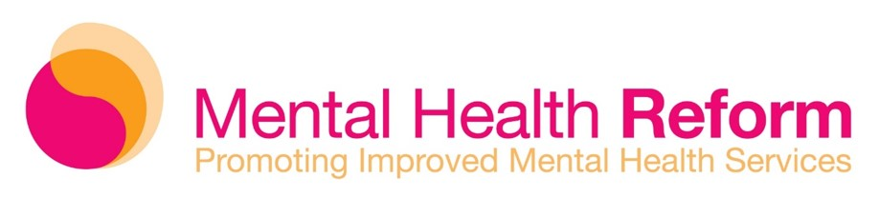

An Taoiseach,   
Mr Simon Harris, TD,  
Government Buildings,   
Merrion St Upper,   
Dublin 2

5th November 2024

Dear Taoiseach,

As independent organisations and voluntary and community organisations concerned with mental health in Ireland, we are deeply disappointed that the Mental Health Bill 2024 will not progress much further before the dissolution of the current Dáil and Seanad in advance of the forthcoming general election.

We would urge consideration of the following urgent and important proposals to help bridge the gap to ensure the Bill’s ultimate passage into law and commencement after the election. Furthermore, we urge the government to give immediate consideration to extend the regulatory powers of the Mental Health Commission with immediate effect. This is possible under the existing Mental Health Act.

In particular, we would urge the following considerations:

* A commitment by all government parties that if returned to power that the Mental Health Bill will be a foremost legislative and policy imperative. The Mental Health Bill 2024 must be reinstated at Dáil Committee Stage within the first 100 days.
* Section 34 of the Mental Health Act, 2001 should be invoked with immediate effect to enable the Minister to extend the regulatory powers of the Mental Health Commission (MHC) to cover non-inpatient statutory mental health services. This must be accompanied by the allocation of concomitant resources to recruit the essential MHC staff for this role. At present, most statutory mental health services based in the community, including CAMHS, are excluded from the remit of the Mental Health Commission. This should happen before the dissolution of the present Dáil and Seanad.

Yours sincerely,

1. Philip Watt, Interim Chief Executive Officer, Mental Health Reform
2. Noel Smyth, Chairman, 3Ts
3. Ken Kilbride, Chief Executive Officer, ADHD Ireland
4. Dara Ryder, Chief Executive Officer, AHEAD
5. Dr Salome Mbugua, Chief Executive Officer, AkiDwA
6. Dr Sheila Gilheany, Chief Executive Officer, Alcohol Action Ireland
7. Seán Moynihan, Chief Executive Officer, ALONE
8. Andy Heffernan, Chief Executive Officer, Alzheimer Society of Ireland
9. Odhrán Allen, Chief Executive Officer, Association of Occupational Therapists of Ireland
10. Suzanne Connolly, Chief Executive Officer, Barnardos Ireland
11. Moninne Griffith, Chief Executive Officer, Belong To
12. Jacinta Hastings, Chief Executive Officer, Bodywhys
13. Michele Kerrigan, Chief Executive Officer, Care After Prison
14. Tanya Ward, Chief Executive Officer, Children’s Rights Alliance
15. Sarah Jane Hennelly, Chief Executive Officer, Community Therapy Ireland
16. Hugh Morley, Head of Business, Cork Counselling Services
17. Brendan McCarthy, Chief Executive Officer, Cork Mental Health Foundation/Housing Association
18. Dr Tracey Monson, Chief Executive Officer, Daughters of Charity Child and Family Service
19. David Carroll, Chief Executive Officer, Depaul Ireland
20. Elaine Teague, Chief Executive Officer, Disability Federation of Ireland
21. John Lannon, Chief Executive Officer, Doras
22. Carol Moore, Chief Executive Officer, Dual Diagnosis Ireland
23. Catherine Kenny, Chief Executive Officer, Dublin Simon Community
24. Helen Ryan, Chairperson, European Association of Professional Hypnotherapists
25. John O'Brien, National Traveller Mental Health Service Manager, Exchange House
26. Ray Cullen, Chief Executive Officer, Futures in Mind
27. Annabel O'Keeffe, Chief Executive Officer, GROW Mental Health
28. Laura Condon, Executive Director, Helplink Mental Health
29. Fiona Tuomey, Chief Executive Officer, HUGG
30. Lisa Molloy, Chief Executive Officer, Irish Association for Counselling & Psychotherapy
31. Andrea Plunkett, Chair, Irish Association of Creative Arts Therapists
32. Caroline Strong, Chief Operations Officer, Irish Association of Social Workers
33. Rúaidhrí O’Connor, Chief Executive Officer, Irish Council for Psychotherapy
34. Saoirse Brady, Executive Director, Irish Penal Reform Trust
35. John Church, Chief Executive Officer, Irish Society for the Prevention of Cruelty to Children
36. Joseph Duffy, Chief Executive Officer, Jigsaw
37. Berni Smyth, Chief Executive Officer, Kerry Diocesan Youth Service
38. Eoin Galavan, Clinical Director, Kyrie Farm
39. Grace Kearney, Head of Health and Wellbeing, National Forum of Family Resource Centres
40. Doireann Croisson, National Women’s Health Coordinator, National Women’s Council of Ireland
41. Mikayla Morton, National Coordinator, Niteline
42. Patrick Reilly, Coordinator Mental Health Initiative, Pavee Point Traveller and Roma Centre
43. Colette Nolan, Chief Executive Officer, Peer Advocacy in Mental Health
44. Stephanie Manahan, Chief Executive Officer, Pieta
45. Dr Odhrán McCarthy, President, Psychological Society of Ireland
46. Sarah O’ Toole, Executive Director, Samaritans
47. Nicola Byrne, Chief Executive Officer, Shine
48. Jess Angland, Chief Operations Officer, Slí Eile
49. Ian Power, Chief Executive Officer, spunout
50. Damien O’ Dowd, Chief Executive Officer, St. John of God Hospital
51. Paul Gilligan, Chief Executive Officer, St. Patrick’s Mental Health Services
52. Joan Wall, Interim Chief Executive Officer, Suicide or Survive
53. Adrienne Kilkenny, Chief Executive Officer, Threshold Training Network
54. Thomas McCann, Director, Traveller Counselling Service
55. Chris Clifford, President, Union of Students in Ireland
56. Peter O’ Toole, Head of Counselling, Wellbeing & Emotional Support, Vision Ireland
57. Siobhán O'Dwyer, Chief Executive Officer, Youth Advocate Programmes Ireland