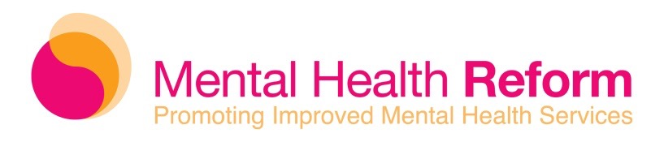

Briefing note on the Mental Health (Amendment) Bill 2017

May 2018

The Mental Health (Amendment) Bill 2017 seeks to update the Mental Health Act, 2001 in a few key ways. It was introduced by Fianna Fáil and has passed all stages of the legislative process in both the Dáil and the Seanad.

The Bill contains certain significant changes that strengthen the rights of people when they are in hospital for mental health care.

The Bill will also support the right of inpatients to make decisions about their own treatment by linking the Mental Health Act, 2001 with recent law that affirms everyone should be presumed to have capacity to make decisions. This includes providing people with the supports they need to be able to make decisions.

The changes in the Bill are:

- Introduce a definition of a ‘voluntary patient’ to include only people who have capacity to make their own decisions (with support if required) and who do give their consent to admission to hospital.

At the moment, people who do not have the capacity to consent to admission and who do not object to admission are being considered voluntary patients, even though they are not able to consent to admission. They do not receive external review of their detention, nor the oversight protections provided to ‘involuntary patients’.

- Replace the existing principle of ‘best interests’ under the Mental Health Act, 2001. This principle has been interpreted very paternalistically in the Courts and has sustained a culture where, at times, the views of the doctor have been given priority over the views of the service user. The Bill would replace ‘best interests’ with the guiding principles of the Assisted Decision-Making (Capacity) Act 2015 (for example, respecting the will and preferences of the person). It empowers people to be the decision-makers over their own care.

The Bill would also introduce the other human rights principles of the right to the ‘highest
attainable standard of mental health’ and the right to ‘least restrictive care’. The Irish
Government is already signed up to these human rights standards.

- Retain the principle of ‘best interests’ in decisions made under the Act (about admission and treatment) for children and young people under the age of 18 years. This is important because it is still appropriate for decisions about children’s and adolescent’s mental health care to be made with ‘best interests’ in mind, in keeping with international human rights law.

• The Bill introduces additional guiding principles in relation to children, including

  - the right to the highest attainable standard of mental health
  - due weight being given to the will and preferences of the child
  - due weight being given to care and treatment being provided, in so far as is practicable, in an age appropriate environment, in close proximity to the child’s home or family and in the least intrusive manner
  - due weight being given to the views of the child (where practicable) in line with the right of the child to be heard, as set out in the UN Convention on the Rights of the Child.

In addition to making some valuable improvements, the Bill is also important because it provides an opportunity to highlight the need to amend the Mental Health Act, 2001 in full and the seriousness of continued human rights violations of people who are being treated in hospital for a mental health difficulty. To date, only one of the 165 recommendations of the Expert Group report on review of the Mental Health Act, 2001 has been implemented. Furthermore, the Government has repeatedly failed to meet its own timetable for updating the Act.

This legislation is positive step towards achieving full amendment of the Mental Health Act, 2001 in line with the recommendations of the Expert Group and Mental Health Reform’s own recommendations. It could contribute, in some part, to the Irish Government’s fulfilment of international human rights law, including under the European Convention on Human Rights and the UN Convention on the Rights of Persons with Disabilities (UNCRPD). Currently, the Mental Health Act, 2001 is clearly not compliant with either Convention.

For further information on the Mental Health (Amendment) Bill 2017 please contact Ray Burke,
Communications and Campaigns Officer at rburke@mentalhealthreform.ie or at 086 171 1920.

Links to resources

- The Mental Health (Amendment) 2017 Bill can be accessed at this link –
https://www.oireachtas.ie/documents/bills28/bills/2017/2317/B23b17d.pdf

- Mental Health Reform’s analysis of the Report of the Expert Group on the Review of the Mental Health Act, 2001 can be accessed at this link - https://www.mentalhealthreform.ie/wp-content/uploads/2015/12/Mental-Health-Act-Review-Analysis_23.11.15.pdf

Assisted Decision-Making (Capacity) Act 2015.
UN Convention on the Rights of the Child.

